* Every file has an address, which we call the "path."; **absolute path** is written **in relation to the computer's root directory**. This URL will only work for you on your computer.
* As no one else has your file system, this URL is unique to your computer. If you want **other people** to be able to **access** it, then you **need an external path.** The computer responsible for giving you a website's files is called a **server**. You can think of **udacity.com as the root path of Udacity's server** (computer) that anyone can access.
* Udacity's servers **run software that expose files** to the web, which means that they make them available to anyone who wants them. Servers have an external path that anyone can access and is the reason why the web works.
* The requesting computers who want access to the external path are the **clients**
* Different protocols for serving files, HTTP and HTTPS are the most common for the web

**What is HTML?**

* **NOT** a programming language
* Markup Language for creating web pages/documents
* **index.html** is the root/homepage of a website
* http://www.something.com
  + Loads the **index.html** file
* http://www.something.com/about.html
  + Loads the **about.html** file

**Inline vs. Block Level Elements**

* Inline Elements
  + Do not start on a new line
  + Take only the necessary width
    - <span>, <img>, <a>
* Block Elements
  + Start on a new line
  + Take full width available
    - <div>, <h1>, <p>, <form>

**All HTML Tags can have Attributes**

* Provide more information about an element
* Placed within the start tag
* Key/value pairs (id=”someID”)

**HTML Forms**

Note: make the look of form w/ HTML, to have any functionality need dynamic functionality

*<form>*

*<label>First Name</label>*

*<input type=”text” name”first-name”>*

*</form>*

* Attribute *action* submits the form to a certain page (like PHP page)
* Attribute *method* (POST or GET): use POST which is secure to add data to a database while get is used for things like search and is not as secure

Labels and inputs are inline elements. Inputs need an attribute *type* (text, number, email, date). Use the tag *<textarea> </textarea>* for things like messages

Use tag *<select> </select>* to provide multiple choices for an input

Use attribute *placeholder=“*_____*”* to put placeholder in the box

Use tag *<input type=“submit” name=“submit” value=“Submit”>*

For buttons, value determines the text on the button

*<button> </button>*

Width and height attribute to <img src=“__” alt=“__” width=“__” height=“__”>

Use tag *<blockquote cite=“__”>____ </blockquote>*

* Abbreviation attribute: *<abbr title=“World Wide Web”>WWW</abbr>*
* Cite tag *<cite> </cite>* (lets browser know that this is something being cited)

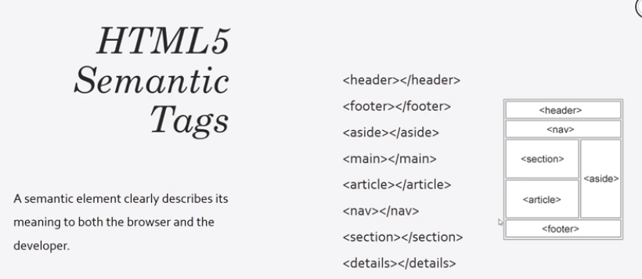

Use *<nav> </nav>* tags when there is some sort of navigation on the page

**What is HTML?**

* Hypertext Markup Language is a fundamental component of every website
* Is a language, but not a programming language - lacks concepts of variables, logic, functions and the like
* Markup language using angle-bracket enclosed tags to semantically define the structure of a web page causing the plain text to be interpreted by the browsers in different ways

The markup allows us to convery extra information about the text we’ve written

Learn about HTML tags is to view the source of a website you frequently visit

**Good HTML Habits**

* The HTML you write should be well-formed - every tag you open should be closed (unless it is a self-closing tag) and tags should be closed in reverse order
* HTML will not necessarily fail with syntax errors if not well-formed
* Use **online HTML validators** to make sure your code is okay